Project Plan

My Web Page - Flat Design

Table of Contents
1. Introduction 3
1.1 Foreword 3
1.2 Background 3
2. Project Organization 3
2.1 Development Model 3
2.2 Project Team 4
3. Risk Analysis 5
4. Hardware and Software Requirements 5
5. Schedule and Breakdown Structure 6
6. Market and Design Research 7

1. Introduction

1.1 Foreword
This website is meant to provide specific information about basics of layout designing and provides tutorial for designing a flat layout design with attention to detail to give the students a just start without overwhelming them.

1.2 Background

Our website aims to provide specific and summarized information about layout designs and focus on flat design with detailed tutorial giving the students a jump start without overwhelming them.

2. Project Organization
A design layout will be created first with the audience in mind. It will be a skeleton of the eventual website without any links. This will server the purpose of how the website will appear to be. This will decide the structure, fonts and color scheme for the website.
Once confirmed, coding will begin to add functionality to the website followed by testing which would also be conducted parallel to the coding.

2.1 Development Model

2.2 Project Team
The table below lists the members of the XXX project team. The project Team consists of xxx

Project Team
Mohammad Omar Munir

3. Risk Analysis

3.1 Risk Analysis
Risk | Affects | Descriptions
Abundant information already available. | View count.. | Generally there is a lot of websites providing information about web design.

3.2 Risk Analysis (i)
Risk | Probability | Effects
Abundant information already available. | High | High competition.

3.2 Risk Analysis Strategy
Risk | Solution / Mitigation
Abundant information already available. | We will narrow our focus on a certain important aspects that would give students a quick start.

4. Hardware and Software Requirements
Adobe Illustrator.
Adobe Photoshop.
HTML5.

5. Schedule and Work Breakdown Structure
< MS Project file and/or Gantt chart>

6.Design: Screen Shots.

Home:
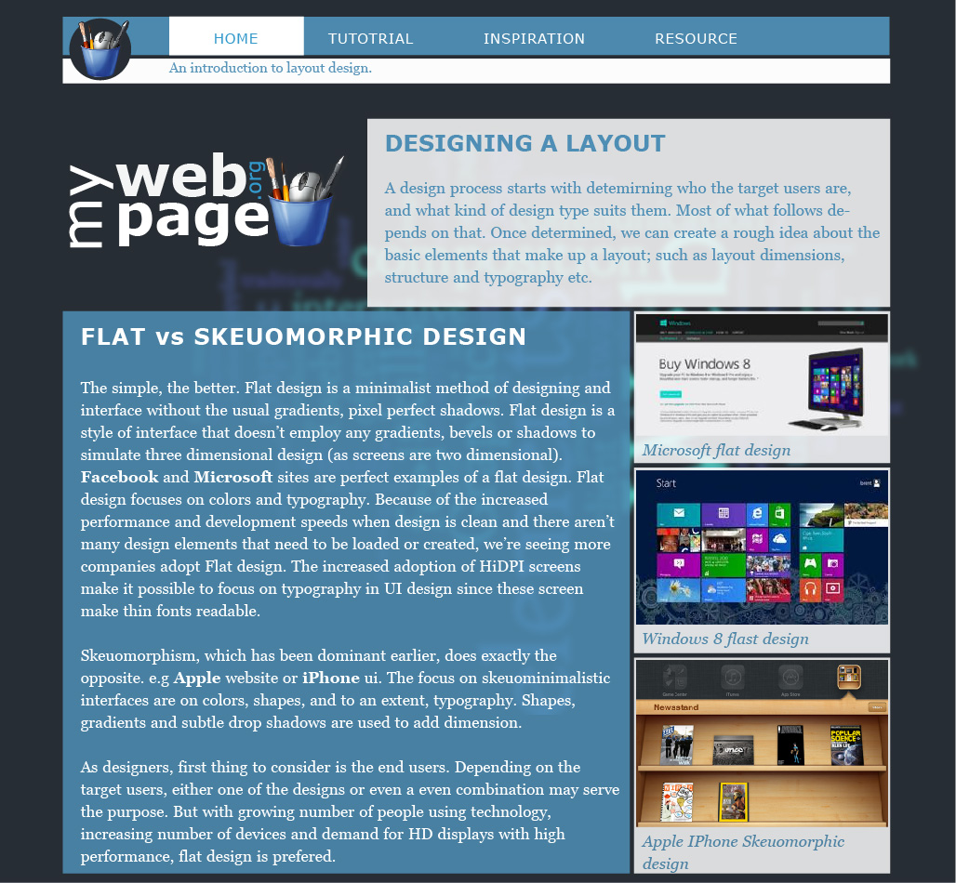

Tutorial: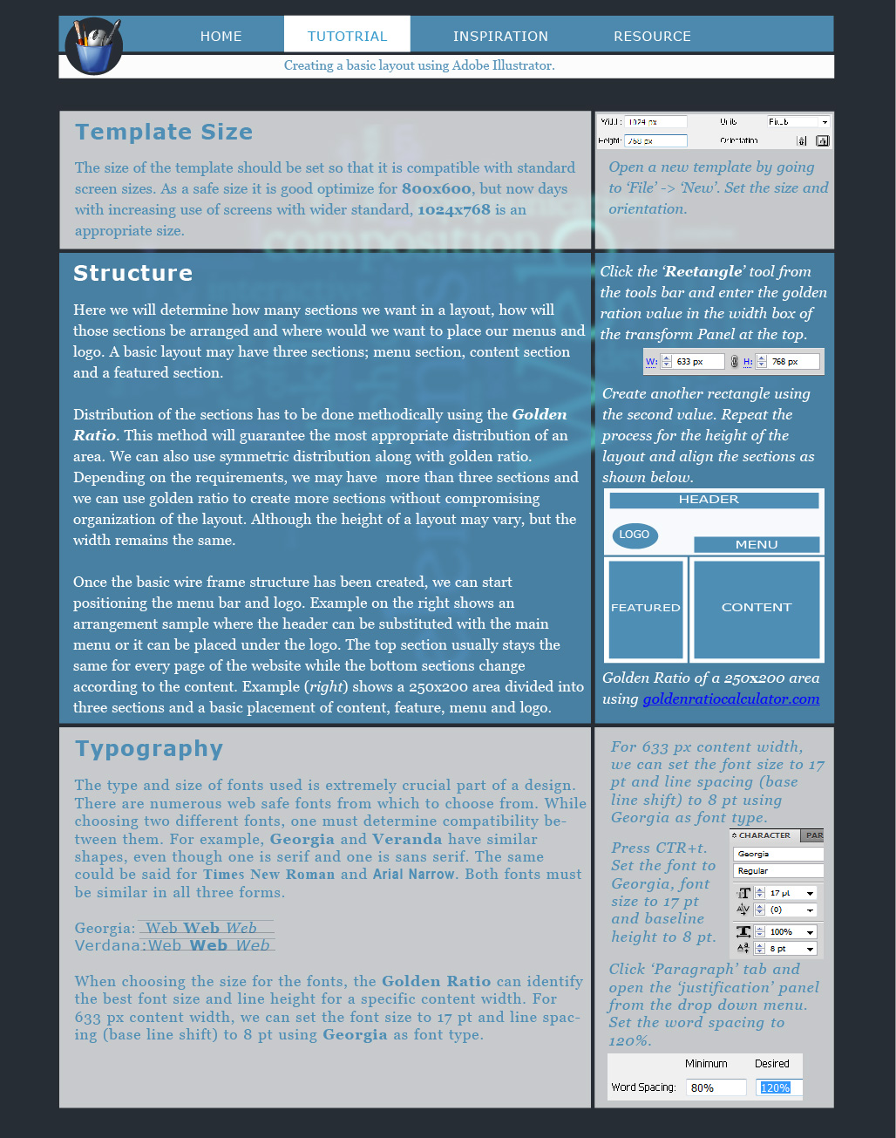
Inspiration:
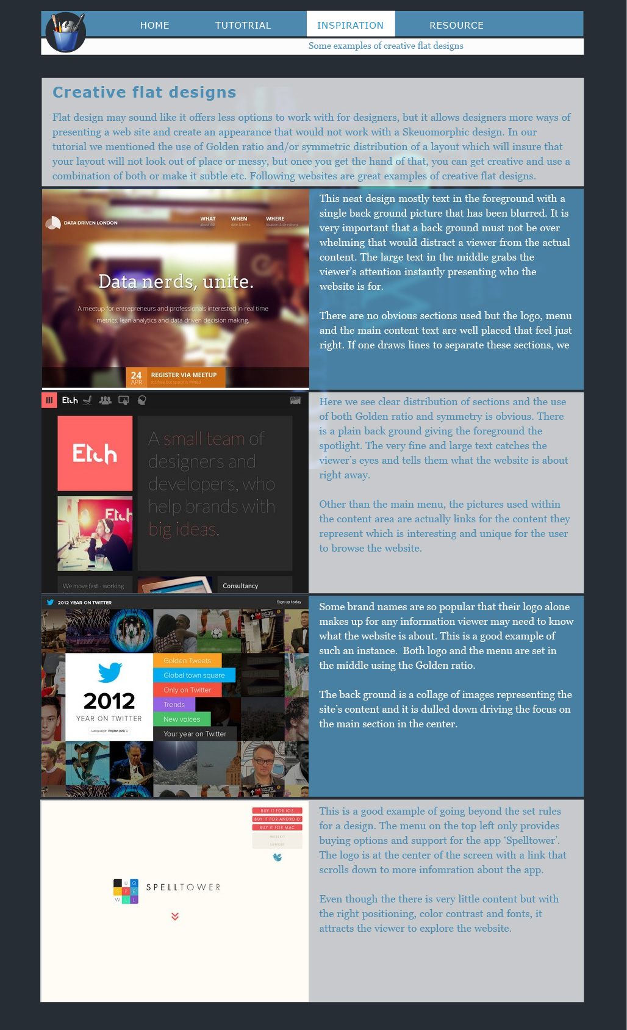
Resource:
